

**Canteen Ordering System**

**Simplilearn CBAP Certification Project 1**

**Project Submitted By** – Ashwini Lanjewar

**Course**- PC-BA-CBAP

**Table of contents**

1. Introduction

1.1Business Analysis Core Concept Model (BACCM)

1. Identify Stakeholders
2. Identify the Problem Statement
3. Identify the Objectives of new COS
4. Create As-is and Future process map
5. Scope of Canteen Ordering System (COS) (Context Diagram)
6. Main features of COS
7. In-Scope and Out-of-Scope items
8. Draw Activity diagram
9. Entity Relationship (ER) Diagram
10. Business Requirements (Functional and Non-functional Requirements)
11. Draw Wireframes for any two features
    * 1. **Introduction**

Unilever is a British-Dutch MNC FMCG company, headquartered in London, England. Unilever is one of the oldest FMCG companies, and its products are available in around 190 countries. In its UK offices, Unilever had around 1500 employees which were spread across twelve floors. They had two canteens to cater to these 1500 employees. Each canteen could seat around 150 employees at a time. Most employees would prefer to take their lunch between 12 noon to 1 pm. This led to a huge rush in the canteen during lunch hours resulting in employees wasting a lot of time waiting for tables to be vacant. Management calculated that it took around 60 minutes for employees to go and come back from lunch. Almost 30-35 minutes were wasted in waiting in a queue to collect their food and get a table to sit and eat. However, the time spent eating was barely 10-15 minutes. The remaining 10 minutes were spent reaching and coming back from the canteen using the elevators. Employees do not always get their choice of food they want because the canteen runs out of certain items. The canteen wastes a significant quantity of food by throwing away what is not purchased. Many employees have requested a system that would permit a canteen user to order meals online, to be delivered to their work location at a specified time and date.

1.1 **BUSINESS ANALYSIS CORE CONCEPT MODEL (BACCM)**

Business Analysis Core Concept Model is a conceptual framework for business analysis. BACCM has 6 core concepts namely: Need, Change, Solution, Context, Value & Stakeholders.

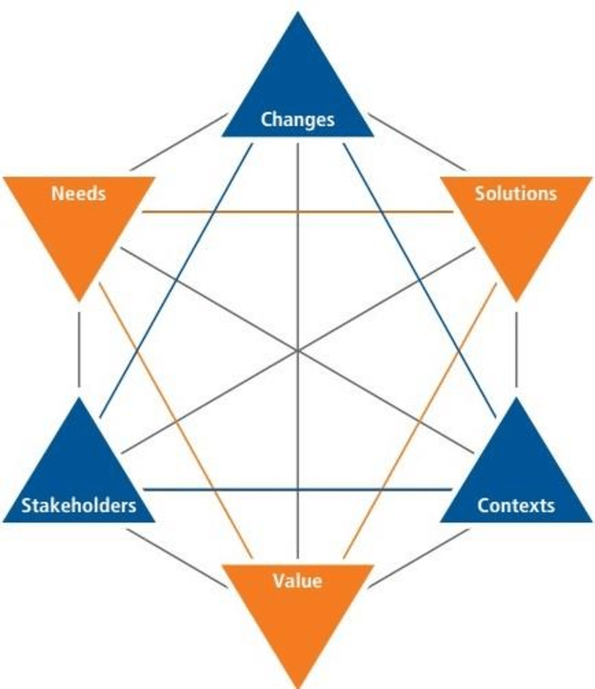

|  |  |
| --- | --- |
| NEED | * Create an online ordering system for Unilever employees. This COS will reduce the amount of time of the employees, food wastage and canteen operating cost. It will increasing effective work time and customer satisfaction. Indirectly it will increase the employee’s productivity. |
| CHANGE | * From traditional process to an Agile Automated process of Online food ordering and delivery to the employee workstation. |
| SOLUTION | * The employee can purchase food through online ordering system and receive it at the on time. * The cost of the food will be deducted from the employee's pay each month. * The delivery agent will place the food on the desk. * Reports generated by the system will support in predicting and analysing employee preferences, hence assisting in decreasing waste. |
| CONTEXT | * Employee wait times ranged from 30 to 35 minutes due to the canteen running out of several dishes. There are two canteens that serve 1500 Unilever employees with a total of 300 seats. * Majority of them liked to eat between noon and 1pm. * Food that was not purchased because of a shortage or no time was wasted. |
| VALUE | * As a result of the automated food ordering process, the canteen will operate with less staff, resulting in lower operating costs. * As a result of various reports like sales, revenue, and preference forecasts, less food will be wasted. * This will increase effective work time by an average of 30 minutes per day. |
| STAKEHOLDERS | 1. Employees 2. Domain SME 3. Delivery Executive 4. Operational/IT Support 5. Canteen Manager 6. Implementation SME 7. Chef 8. Tester 9. Payroll Team 10. Project Manager 11. Inventory Supplier 12. Unilever Management |

* 1. **Identify Stakeholders**

Stakeholder is an individual or a group who are directly or indirectly impacted by the need, change or a solution or that a BA is likely to interact with directly or indirectly.

|  |  |
| --- | --- |
| **Stakeholder** | **Using COS** |
| Employee | * The employee will be able to receive their food at the appointed hour. * Employees won't have to wait in line for a long time and may place an order from a choice of foods with just a few clicks on the app or website. * • If customers make an order before 11am, they will receive the dishes of their choice. * Payment method is very smooth as it will straight be deducted from their salary * Feedback of process/application/Website can be shared. |
| Project Manager | * Check whether the work of developing the app or website was completed within the Timeframe. * Ensure that everyone is on the same page with the goal. |
| Implementation SME | * Develops the online ordering system |
| Tester | * Will check the website's or application's quality. * Will carry out a quality analysis to determine whether the product is ready before it is released and to identify any bugs or problems. |
| Domain SME | * The application/website building, prototype, and testing will be acknowledged by the domain SME if they fulfil the client's standards or expectations. |
| Operational/IT Support | * Will offer support, when necessary, in managing a variety of operational tasks, such as coordinating between departments and managing calendars to ensure task completion on time. |
| Business Analyst | * Identify the problem and find a workable solution * Communicate with each stakeholder and produce the necessary documentation and BA deliverables. |
| Canteen Manager | * Modify and update the menu. * To keep track of whether an order has been placed and allocated to the chef or not. * Make sure the ticket is closed by the delivery executive once the order has been successfully delivered. |
| Chef | * Make sure the food is cooked in accordance with the order requirements and on time considering the delivery time. * As soon as the meal is picked up for delivery, make sure to notify and shut the order. |
| Delivery Executive | * Deliver the food at the designated time to the employees' desks in accordance with the order details * Close the docket once the food has been delivered. |
| Payroll Team | * The payroll team will review each employee's total monthly orders, and the team will deduct the entire cost of all the meals bought in a month from each employee's salary. |
| Inventory Supplier | * Track employee feedback received and determine any necessary changes. |
| Unilever Management | * Supply the inventory needed by the canteen manager on time. |

**Stakeholders Onion Diagram**

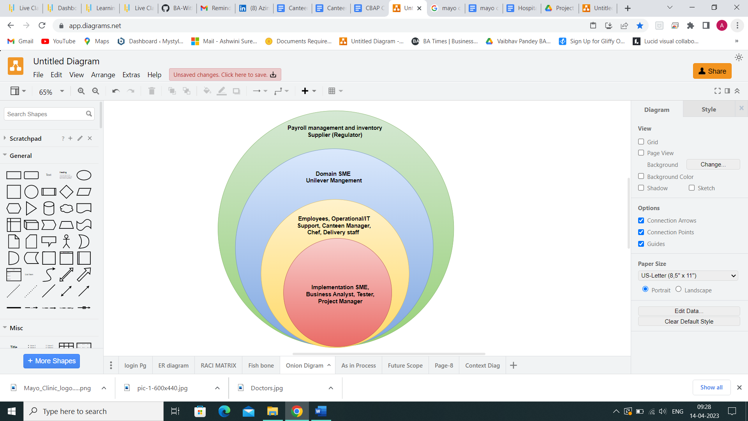

**RACI MATRIX**

RACI matrix is used here for identifying the responsibility of each stakeholder involved in the process:

* Responsible (R): The people who will perform the task's work.
* Accountable (A): The people who make the decisions and are ultimately responsible for the task's completion.
* Consulted (C): Stakeholder or group of stakeholders, who are in loop and are asked to provide an advice/suggestion/information about the task. It is a two- way communication
* Informed (I): Stakeholder or group of stakeholders is kept up-to-date about the task and its outcome. Here, the communication is one-way.

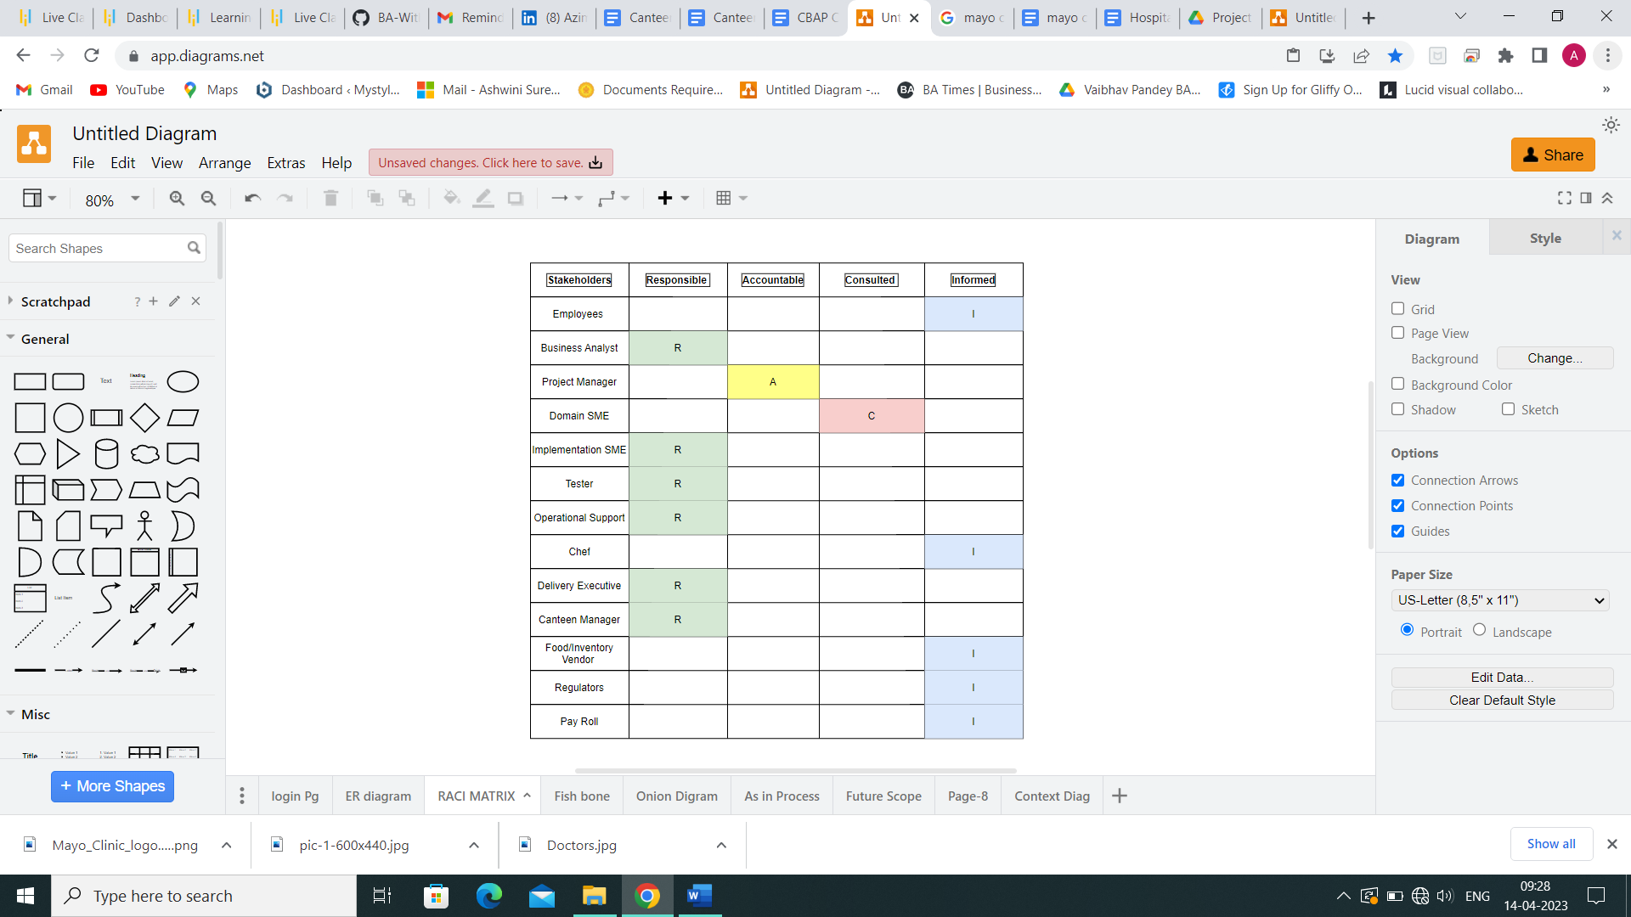

* 1. **IDENTIFY THE PROBLEM STATEMENT**

1500 people worked for the UK branch of Unilever across 12 floors. There were only 2 canteens, with a total seating capacity of 300 workers.

The majority of employees opted to eat lunch between 12 and 1 pm, which caused a rush and long queue in both canteens. As a result, employees had to wait a long time for their meals.

Management estimated that it takes an employee about 60 minutes to arrive and return, and that it often takes 30 to 35 minutes to get an order served and a seat at a table, wasting about 50% of the employee's lunch hour.

10 to 15 minutes are spent eating, while the final 10 minutes are used to get to and from the canteen via elevators.

Employees frequently find that the canteen is out of their preferred meal. Given that it was not purchased, the canteen throws away significant amount of food which is not purchased.

**FISH-BONE DIAGRAM**

***Root cause analysis of the problem statement is shown in this Fish-bone Diagram*:**

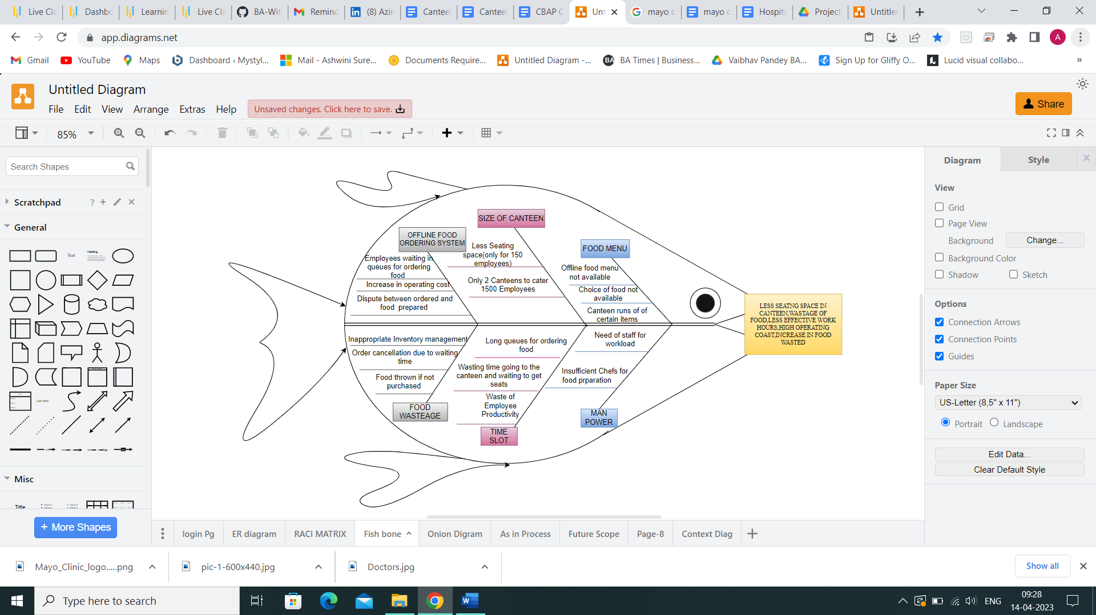

* 1. **OBJECTIVES OF THE NEW CANTEEN ORDERING SYSTEM**

**Business Objective 1:**

Reduce canteen food wastage by a minimum of 30% within 6 months following first release.

Scale: Value of food thrown away each month by examining the canteen inventory

Previous - 25% wasted

Must plan for: Less than 15%

**Business Objective 2:**

Reduce canteen operating costs by 15% within 12 months, following initial release.

**Business Objective 3:**

Increase average effective work time by 30 minutes per employee per day, within 3 months.

**Business Objective 4:**

By making the ordering process automated and by delivering the food to the user's workstation, the canteen will be able to operate with lesser manpower.

* 1. **AS-IS AND FUTURE PROCESS MAP**

**AS-IN PROCESS**

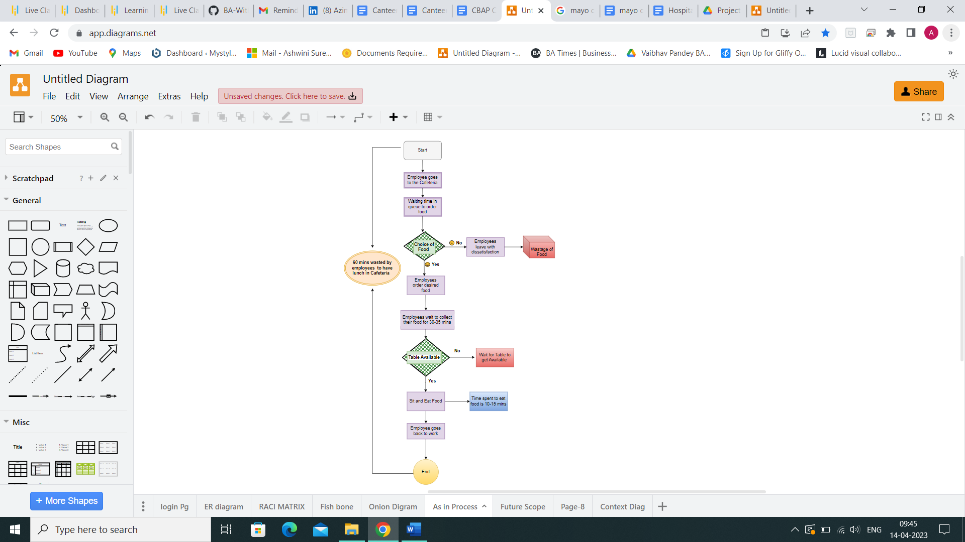

**FUTURE SCOPE MAP**

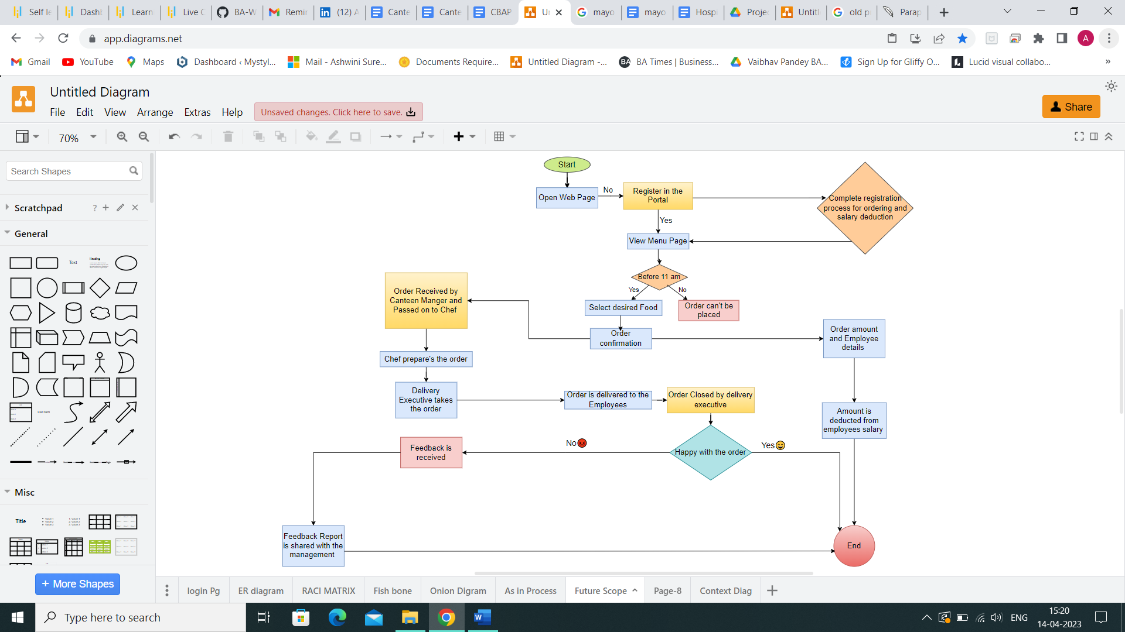

* 1. **SCOPE OF THE CANTEEN ORDERING SYSTEM**

**The scope of the canteen ordering system is displayed below in the form of context diagram:**

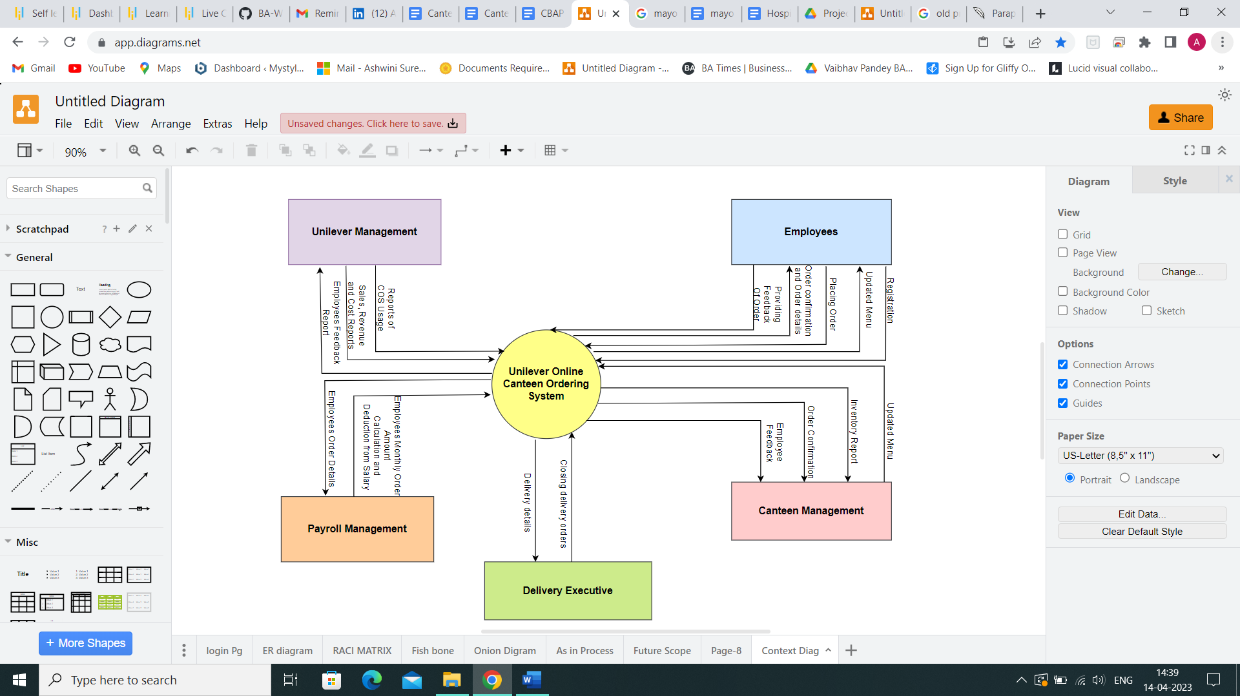

* 1. **Main features of COS**

1. Online food ordering system that caters 1500 employees.
2. Employee Login and registration system
3. When the login is successful the employee should be able to view food menu.
4. The orders cannot be made after 11 AM, so that the chef has sufficient time to prepare the lunch for the orders received.
5. Order confirmation and checkout.
6. The canteen manager should be able to view the order and communicate the chef for order preparation.
7. Then the prepared food to be packed and handed over to the delivery person for delivery.
8. After delivery the delivery person should be able to close the order.
9. Post completion of the delivery, employees should have option to provide feedback.
10. The system that provides calculated the total number of dishes ordered that will be deducted from the employee’s monthly salary.
11. Generation of required reports by the management.
    1. **IN-SCOPE AND OUT-SCOPE ITEMS FOR THIS SOFTWAFRE**

**IN-SCOPE ITEMS**

* Employee can login using login credentials for registered employees
* A register section for unregistered employee
* Only 1500 UK Unilever Headquarters Employees can order
* Canteen Manager can Create, Read, Update & Delete the Menu
* Up-to-date Menu
* Orders shall be placed before 11AM
* Before placing final order, employee can edit or change it
* Once the order has been verified and checked out, the employee cannot make any changes to, edit, or cancel it.
* The canteen manager will be able to see the order and update the inventory as necessary.
* Canteen Manager will be able to raise Delivery Request
* Chef will be able to Notify when Order is ready. Canteen Manager will be able to raise Delivery Request.
* After picking up and delivering the order to the employees' workstations, the delivery executive will close the docket in the system.
* Employee can give Feedback of Food Quality and service; they should be able to submit the feedback
* The payroll team will have access to the employee's food order information and will be able to monthly deduct the whole cost from the employee's salary.
* Management will have access to daily, weekly, monthly, and annual reports on sales and revenue.

**OUT-OF-SCOPE ITEMS**

* No-other Employee besides Unilever UK Headquarters 1500 Employees will be able to order through this system
* Food Vendor Management
* Canteen-Staff Payment Management
* System will not accept order after 11AM
* After checked out- employee cannot edit, change or cancel the order
* Refund option
* Delivery for non-organizational people.
  1. **Activity Diagram**

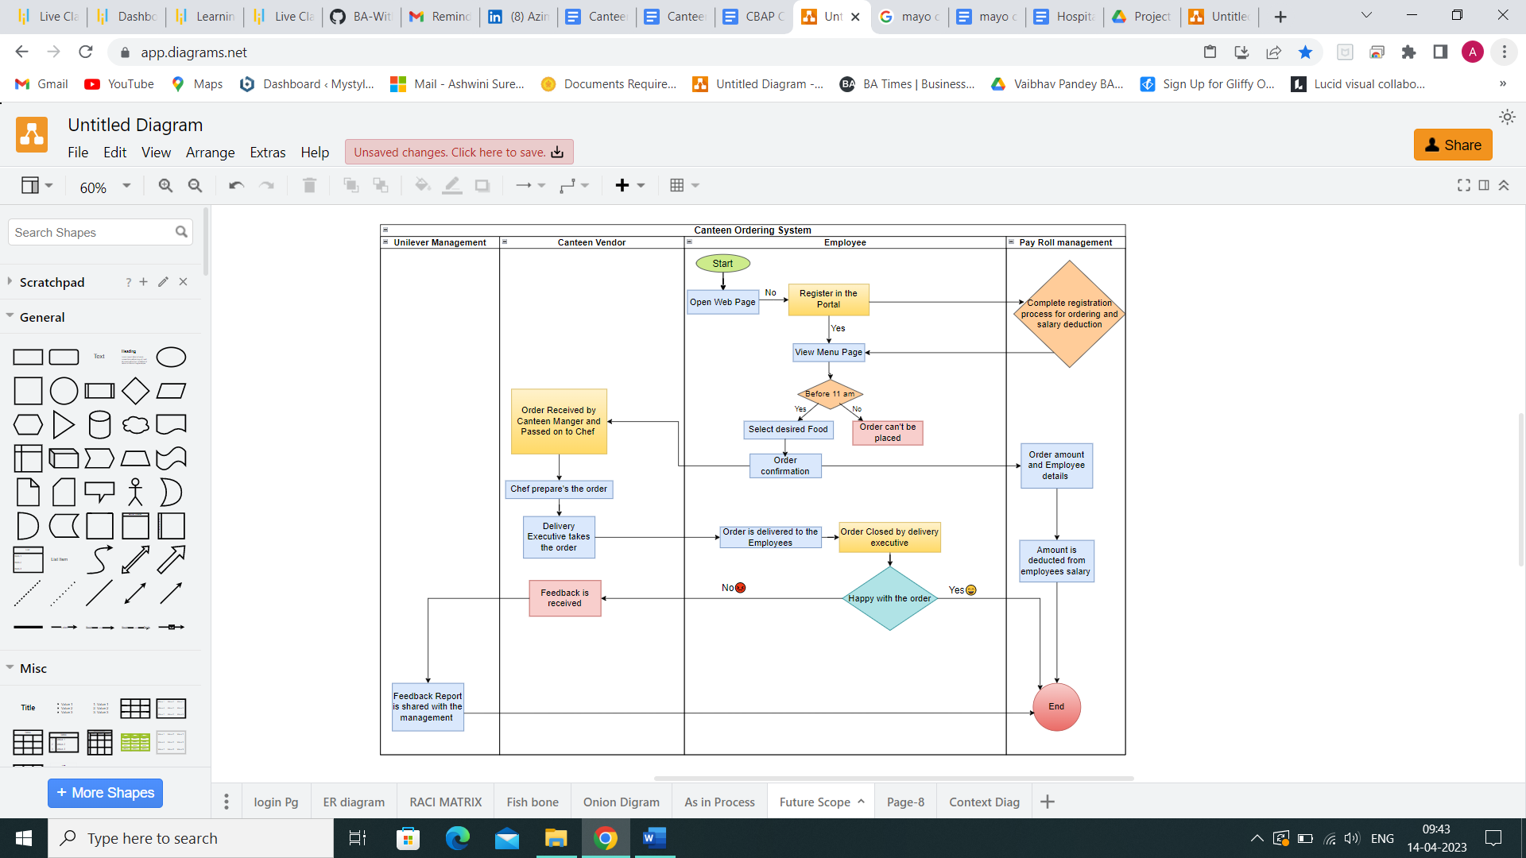

* 1. **ER Diagram**

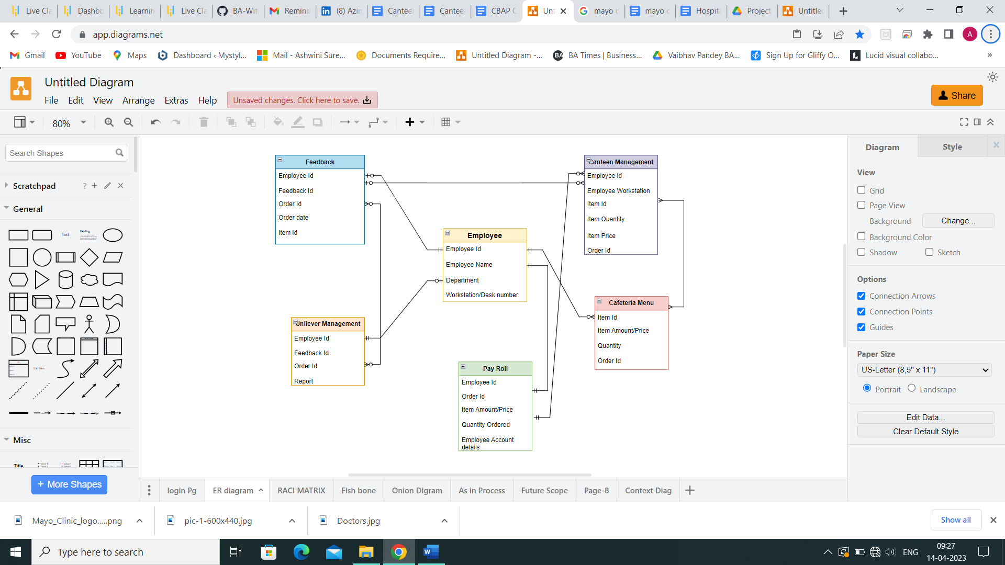

* 1. **Functional and Non-Functional Business Requirements**

**BUSINESS REQUIREMENT**  
The Business requirements are as follows-

* Reduce the canteen operating cost by 15% within 12 months.
* Reduce canteen food wastage by a minimum of 30% within 6 months.
* Increase average effective work time by 30 mins per day per employee within 3 months.
* Making the canteen ordering system automated which will deliver the food at employees’ workstation at specified time which will make the canteen run on lesser manpower.

1. **Functional Requirements:**

* Employees and Login/Sign in
* Automating food ordering through the creation of an application
* The canteen manager regularly creates and update the menu
* Food is delivered to every employee's desk
* The delivery person closes the order after it has been delivered
* The employees be able to provide feedback on the food
* The payroll system manage payment for the order by calculating the total number of dishes that each employee has ordered and deducting that amount from their salary each month
* Generate Reports as required by the management
* Most popular dishes
* How many employees are using the system?
* Feedback from the employees
* Sales for each day
* Total monthly earning
* Order forecasting

1. **Non- Functional Requirements**

* The COS should be able to accommodate 1500 personnel at once
* The interface should be accessible, interactive, and easy to understand
* The system should provide only accurate reports
* The system's overall performance should be quick, effective, and time-efficient
* The system should be compatible with all devices, including Android and iOS.
  1. **Mock Screen/ Wireframe of COS**

